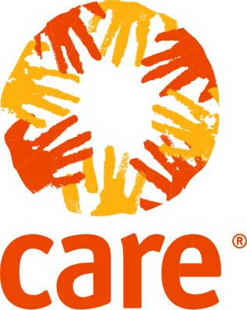**Program Brief**

**Bintang Muda: Investing in young women to transform their futures**

**OVERVIEW** Bintang Muda is a unique partnership between CARE and the H&M Foundation, working to empower young women in poor communities to start up or expand their businesses.

**EMPOWERING WOMEN, SUPPORTING COMMUNITIES**

CARE's Bintang Muda project, based in Makassar in South Sulawesi, supports **young women entrepreneurs to develop or enhance their own micro businesses.**

Bintang Muda focuses on building women's **confidence** in making decisions that affect their business, teaching women participants **new skills** in business management and growth, and helping participants to **build networks** with other entrepreneurs. Since the Bintang Muda partnership started, **over 200 women have received training and**

**coaching in business management,** risk management, marketing and enterprise development, and a further 2000 women have received information and mentoring on financial literacy and business development.

The training and mentoring provided by CARE includes **practical information for participants** on how to make improvements to their current business to help them to stay competitive. Such improvements might include changes to product branding, packaging, engaging in online marketing, and working to ensure products are approved by and receive necessary certification and licenses from relevant authorities to make them eligible for wholesale.

CARE also provides training on **disaster preparedness,** to ensure the businesses are resilient to environmental and other shocks.

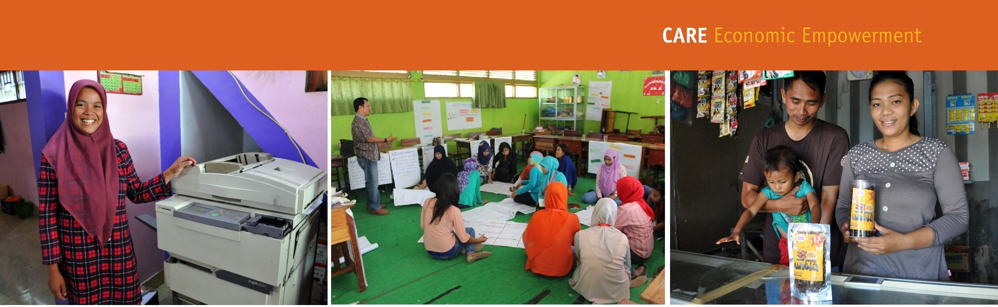

**Indonesia is home to 65 million young people aged 16-24, and while the country is making positive economic gains, youth unemployment remains a major challenge. Issues of poverty and injustice are at the root of unemployment issues, as well as the cultural dynamic which prevents women from fully participating in the workforce.**



“



.”



CARE INTERNATIONAL INDONESIA

